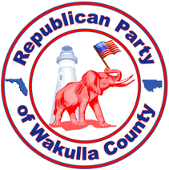

Freedom Scholarship 2024
The Wakulla Republican Executive Committee (WREC) invites promising 2024 High School Seniors to compete for $1,000 Freedom Scholarships. The purpose of the scholarships is to encourage students to be involved in our community, support their commitment to advancing their education or training, and promote the importance of our freedoms under the United States Constitution. Through these scholarships, Wakulla Republicans seek to enrich the political awareness of our youth to the benefit of our local community and our nation.
For the graduating class of 2024, the WREC is awarding six scholarships of $1,000 each. Three (3) boys and three (3) girls will be awarded scholarships based on qualifying and competitive applications.

Eligibility:
- 2024 High School Graduate (Wakulla County public, private, or homeschool)
- Must be a registered Republican (or pre-registered)
- Entering an accredited college, university, vocational school or certification program, law enforcement, or armed services.
- Resident of Wakulla County, Florida
- Photo Identification
- Post-secondary Acceptance Letter or Notice
- Essay or Video up to 750 words on Freedom
- Complete 2024 Freedom Scholarship Application

Schedule:
- April 12, 2024 deadline for submission to WakullaGOPYouth@gmail.com
- April 19, 2024 notice of awards.
- May 13, 2024 requirement to attend WREC meeting to receive the Freedom Scholarship Award

